Android Studio provides the fastest tools for building apps on every type of Android device.World-class code editing, debugging, performance tooling, a flexible build system, and an instant build/deploy system all allow you to focus on building unique and high quality apps.

My post have 2 part :

1. Dowload

2. Install Android Studio

**System requirement:**

* **Microsoft® Windows® 8/7/Vista/2003 (32 or 64-bit)**
* **2G hardisk space**
* **Java Development Kit (JDK) 7**

**1.Download**

You can download here : <https://developer.android.com/sdk/index.html>

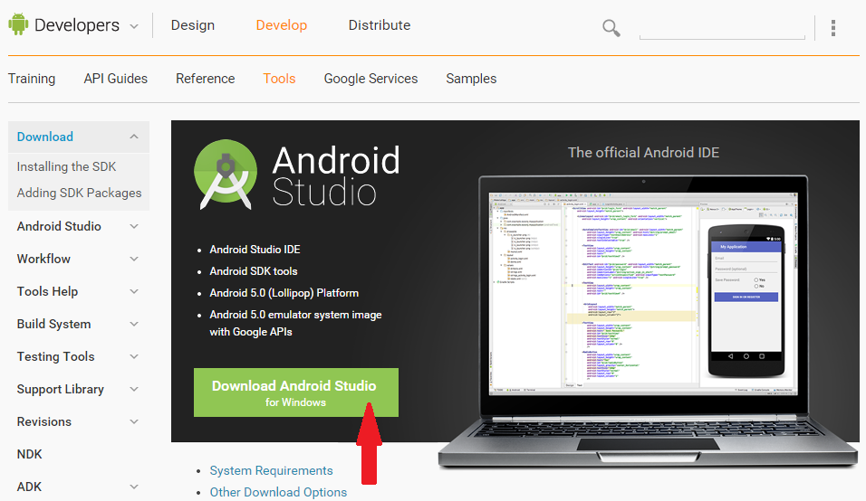

**2. Install Android Studio**

After download successfully, you click file **android-studio-bundle.exe,** welcome dialog will show :

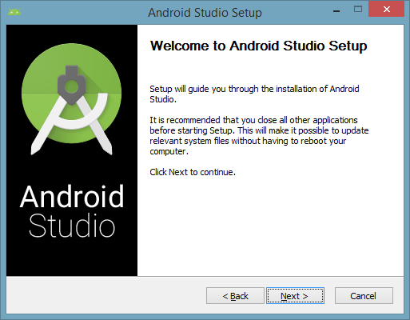

Click **Next** to continue, if your system don’t have JDK, the dialog will require path JDK or setup JDK :

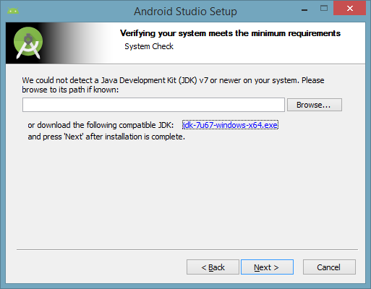

Click **Next,** you should check all selectbox:

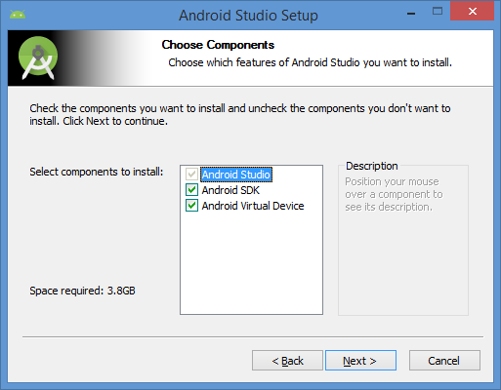

You click **I Agree** to continue :

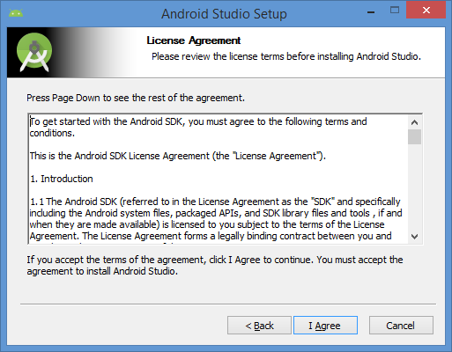

You choose path to setup Android Studio and Android SDK :

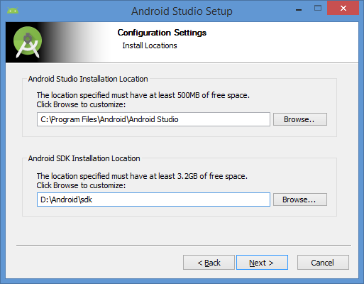

Click **Install**  and wait:

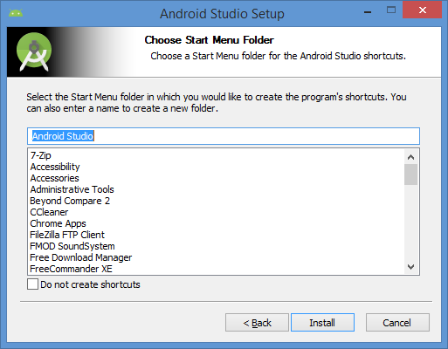

When the installation process finish, you click **Next :**

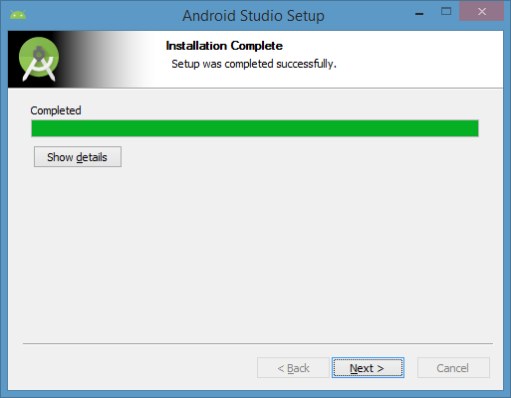

And you can start Android Studio :

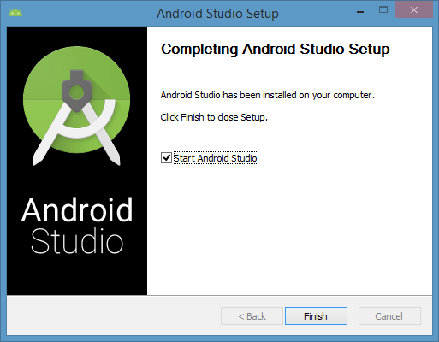

At first boot times, an import dialog box appears the old Android Studio, if you install a new, please select the picture below :

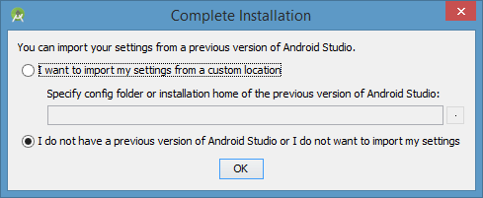

Click **Ok** and continue, you have to update anything. Please wait until completion.

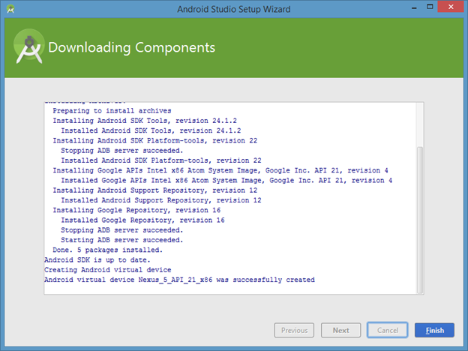

Thats it. Really simple as it should be.

**See you at the next! Thanks you!**